**Challenge 14**

[www.pythonchallenge.com/pc/return/italy.html](http://www.pythonchallenge.com/pc/return/italy.html)

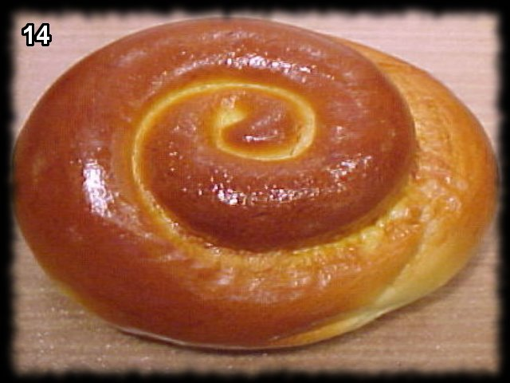

So, a picture of a roll? The title is ‘walk around.’ Below that is a rectangle that is lines kind of like a bar code.

There is a clue in the page source: <!-- remember: 100*100 = (100+99+99+98) + (... -->

This looked mathish to me, and I was happy. Played around with series and pascal’s formula and fun stuff – but to no avail. Did other stuff for a while and then cheated. Again, really easy when someone explains things.

I did notice that the bar code looking thing **wire.png** was of length 10000 = 100 x 100. The thing to do is think of it as a wire and spiral it around a 100 x 100 image (right down left up) (or maybe ccw if image looks backwards.

The new picture is a cat. ‘cat.html’ leads to message that the cat’s name is ‘uzi’ (and you’ll see him later). So ‘uzi’ goes to next challenge.